“Asthma Doesn’t Stop Me”
A fun approach to provide asthma education to children with asthma & their families in a practice setting. Patient education during office visits can be a challenge. A hands-on, interactive, group -teaching program can be an effective way to provide education. Once a year, set up the office to function as a revolving education center. Families work their way through an organized system of stations where they learn about asthma and how to manage it. The stations efficiently reach many children and adults at once. At Renaissance Pediatrics in Chesapeake, families look forward to Asthma Days each October. Dr. Sandra Baucom and her staff have conducted Asthma Days annually for 9 years. Suffolk Pediatrics has a similar program. See below for helpful hints for setting up Asthma Days in your practice:
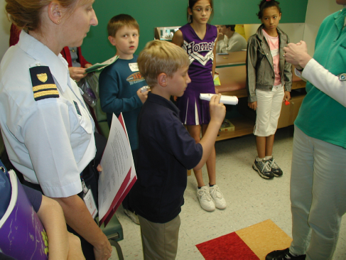
General
- Make stations fun and interactive
- Invite all children with asthma
- Schedule return appointments to occur during event
- Enlist commitment from entire staff - make sure everyone has a role
- Be mindful of documentation and coding for proper reimbursement
Registration Center
- Include a packets to give to each parent that includes: asthma action plan, consents necessary for activities, event evaluation form, asthma assessment checklist, and flu vaccine information sheet with consent
- Punch cards for participants help keep track of which stations they have visited

Spirometry- results interpreted by provider during visit

Physical exam – by a nurse practitioner or physician

Peak flow meters- use of pfm, explanation of zones
- Measure each participant for their zone
- Demo pfm, then each child returns demo and receives pfm if they don’t have one

Allergies - discussion of allergies and eczema.
- How to properly use nasal sprays
- How to reduce allergens in bedroom and home

Lung anatomy- how lungs work
- Construction paper cut outs of lungs for kids to glue and color
- Posters of lungs
- ALA loans of actual cadaver lungs (one healthy and one diseased as a result of smoking)

Relaxation - techniques for relaxation, including belly-breathing

Symptoms –
- Coloring page for kids of lungs and airways
- How to recognize symptoms, warning signs and triggers.

MDI / Spacers- All equipment and medication delivery systems are discussed
- Demonstrate equipment – give spacers if they don’t have them
- Show how to float test MDI’s

Flu shot- last station!

